Kellen Hunter

09/03/20

IT FDN 110 A

Module 9 - Assignment 09

URL:

Connecting Modules Together

# Introduction

This week I learned how to write code once and use it over and over again. Modules are helpful to break up code into separate sections. This helps the coder organize code better so it can modified quicker. A module cam define functions, variables and classes. The import statement is used to call up modules into the “main” python file. This file is where the main body of the code is stored.

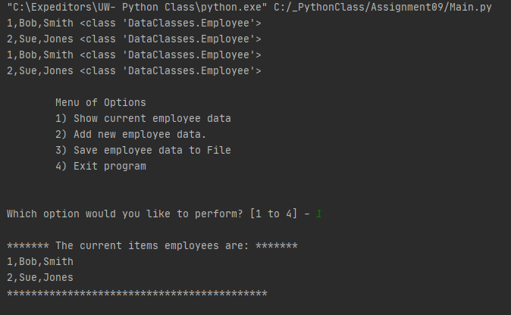

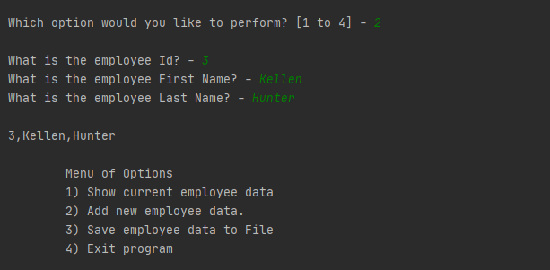

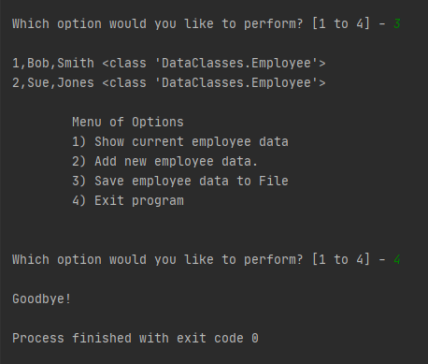

**Input Code in PyCharm**

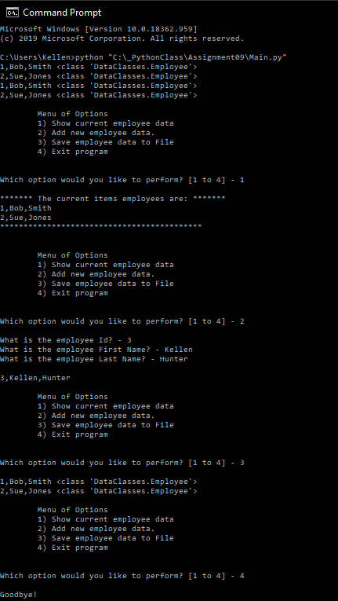

**Picture of code compiling in Command Prompt.**

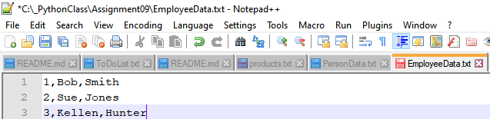

**Picture of EmployeeData.txt File.**

# Summary

This week I was able to separate my code into separate modules and call up those modules into a main script. The separate modules helped me organize my code better. So when something needed to be updated or changed I could quickly access the correct module update the code and rerun. Saving these modules as template could help a coder finish project faster.

# Sources

<https://www.w3schools.com/python/python_modules.asp>

<https://www.geeksforgeeks.org/python-locals-function/>

<https://realpython.com/python-modules-packages/>

<https://www.tutorialspoint.com/python/python_modules.htm>